**Week 2**

1. **Write a function greet(name) that takes a name ehich is store in variable as input and prints "Hello, [name]!".**

def greet(name):

print(f"Hello {name}")

greet("test")

**# Output:**



1. **Create a function square(num) that returns the square of a given number.**

def square(num):

sq = num * num

print(f"square of {num} is {sq}")

no = int(input("Enter Number : "))

square(no)

**# Output:**

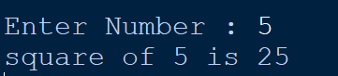

1. **Write a function is_even(n) that returns True if a number is even, otherwise False.**

def is_even(no):

if (no % 2 == 0):

print(f"{no} is even number.")

else:

print(f"{no} is odd number.")

no = int(input("Enter Number : "))

is_even(no)

**# Output:**

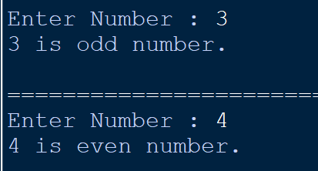

1. **Define a function sum_numbers(a, b=10) that takes two numbers and returns their sum. If the second number is not provided, it should default to 10.**

def sum_numbers(a, b):

sum = a + b

print(f"sum of {a} and {b} is {sum}")

a = int(input("Enter the first number: "))

b = input("Enter the second number (press Enter to set default value): ")

b = int(b) if b else 10

sum_numbers(a, b)

**# Output:**

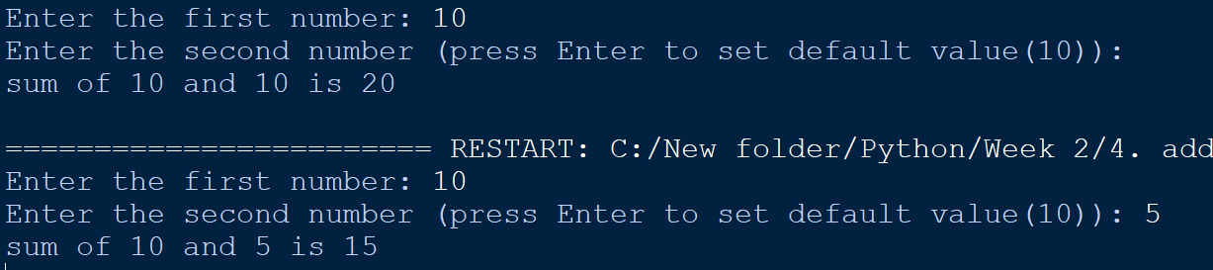

1. **Write a recursive function factorial(n) to calculate the factorial of a number.**

def factorial(n):

if n == 0 or n == 1:

return 1

else:

return n * factorial(n - 1)

num = int(input("Enter a number: "))

if num < 0:

print("Invalid Number.Please Enter Positive number.")

else:

print(f"Factorial of {num} is {factorial(num)}")

**# Output:**

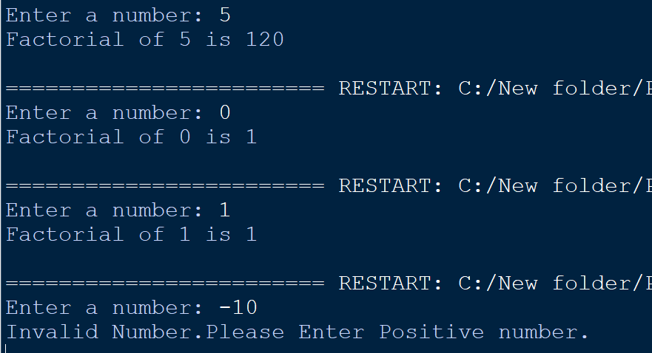

1. **Use a lambda function with filter( ) to get all even numbers from a list: [1, 2, 3, 4, 5, 6, 7, 8].**

numbers = [1, 2, 3, 4, 5, 6, 7, 8]

even_numbers = list(filter(lambda x: x % 2 == 0, numbers))

print(f"even numbers in the list are {even_numbers}")

**# Output:**



1. **Write a while loop to print the first 5 multiples of 3.**

n = 1

i = 1

while(i <= 5):

print(3 * n)

n += 1

i += 1

**# Output:**

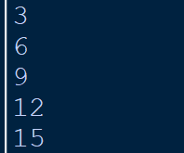

1. **Create a loop that prints all numbers from 1 to 20 but skips multiples of 5.**

i = 1

while (i <= 20):

if (i % 5 != 0):

print (i, end = " ")

i += 1

**# Output:**



1. **Write a loop that stops when it encounters the number 7 in this list: [1, 2, 3, 4, 5, 6, 7, 8, 9].**

list1 = [1, 2, 3, 4, 5, 6, 7, 8, 9]

for i in list1:

# print(i) (if we want to print 7, assuming not)

if i == 7:

break

print(i)

**# Output:**

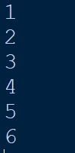

1. **Write a program that checks if a year is a leap year. (Hint: A year is a leap year if it is divisible by 4 but not by 100, except when it is also divisible by 400.)**

def leap_year(year):

if (year % 4 == 0 and year % 100 != 0) or (year % 400 == 0):

return True

else:

return False

year = int(input("Enter a year: "))

if leap_year(year):

print(f"{year} is a Leap Year.")

else:

print(f"{year} is not a Leap Year.")

**# Output:**

